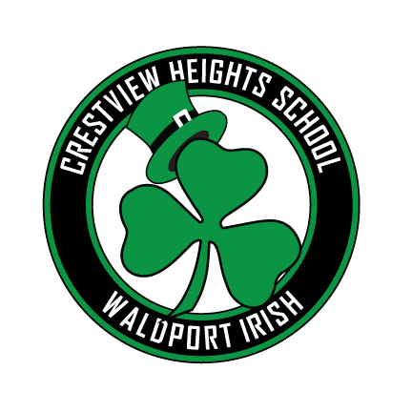

# Crestview Heights Elementary

Volume 2 Issue 7 March, 2019

## Our School Family Newsletter

If you would like to attend one of the Cielidhs, please visit the Crestview Heights web page and sign up on the doodle poll. We will have these for the rest of the year as well as next year. The location as well as times and dates will be on the Doodle Poll when you sign up. Thank you for your continued support for the staff and students at CVES.

## A Message from the Principal

Research supports that small groups allow participants to be heard in a more comfortable, informal environment and more willing to share their feelings and concerns. We are referring to these listening sessions as Ceilidh, which is a type of Irish social gathering.

As the principal of Crestview Heights, I would like to begin bringing the school and the community together in order to reestablish trust by providing some collaborative listening sessions. My plan is to provide two sessions each month. We will meet with a group of no more than 5 individuals.

MARCH 2019

Monday 4th Official start of CVES Read-a-thon

Monday-Friday 4th-8th Classified Week – Celebrating this amazing staff

Wednesday 6th

Seashore Family Literacy with Dr. Gray

5:30 dinner, 6:00 program

Thursday 7th

Site Council CVES 4:30-5:30 in library

Thursday 7th Ceilidh DaNoble House 6:00-7:00

Tuesday 12th Boosters meet at 6:00 in the library

Thursday 14th Art Show. Dinner begins at 5:30

Tuesday 19th Ceilidh

CVES Library 5:00-6:00

Monday –Friday 25th to 29th SPRING BREAK

### IRISH Got Talent?

### 40-Day Character Strong Challenge

The Boosters are so excited to announce the upcoming “Irish Got Talent” Show. This will not be a competitive event; instead it will be an opportunity for students and staff to show their strengths. Details and interest forms will be coming home along with this newsletter.

We are on week 5 of our 40-day challenge, which will take us up to spring break. Students have been talking about, reading about, and demonstrating kindness, patience, honesty, forgiveness, commitment, selflessness, respect, and humility.

### CVES Art Show

### Read-A-Thon

Be sure to join us for the “Every Child is an Artist” Event, March 14. Enjoy a free dinner, gallery walk featuring student and local artists’ masterpieces, as well as a student art raffle and silent auction of locally donated artwork. Buy your raffle tickets for student artwork early and enjoy the evening! Pre-sale of student art raffle tickets are $1.00 for 5 tickets until March 13th. At the event, they will be $1.00 for 4 tickets. All proceeds benefit the CVH’s art program. There will also be a bake sale to support the Waldport Middle School East Coast trip.

The Read-A-Thon, which does not officially start until Monday, has already made over $600.00. Proceeds from Crestview’s Read-A-thon will go to creating collaboration opportunities between classrooms and the library by purchasing books that will support STEM activities.

On Wednesday, March 6, come and enjoy a free community dinner hosted by Seashore Family Literacy Center with guest speaker Dr. Karen Gray, Superintendent of LCSD. Dr. Gray will be speaking on the topic of bullying – what it is and how it is address in our schools. Question and answer session to follow. Spaghetti dinner begins at 5:30, with the session from 6:00 pm until 7:00 pm.

### An Evening LCSD Superintendent

### Positive Behavioral Expectations

It’s a good day to be Irish!

BEing SAFE * BEing HELPFUL

and BEing KIND

To receive emails or text messages through REMIND for Crestview Heights, follow these directions:

**TEXT** - Enter 81010 then text this in the message: @toneca

**WEBSITE** - Visit the following website and follow directions: [www.remind.com/join/toneca](https://www.remind.com/join/toneca)

Our School Family Newsletter