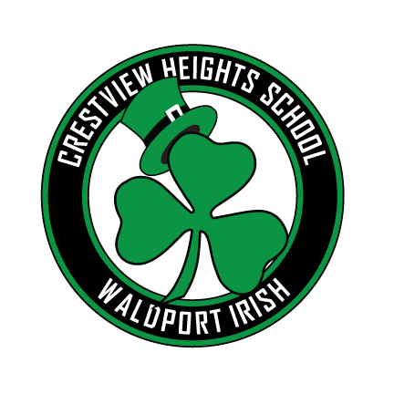

# Crestview Heights Elementary

Volume 2 Issue 8 April, 2019

## Our School Family Newsletter

## A Message from the Principal

1st Place – Keelah Ford and Nakeline “Sugar” Booker, CVH, 4th Grade, teacher: Melaia Kilduff

2nd Place – Alexys Leon, Christian Garcia-Smith, Joseph Huffman, Lacey McBride, Grades 3/4, CVH, teacher: Sheryl Saxton

3rd Place –  “Tornado Turbines” Eli Woodbridge (3rd) Mattison Frank, Ava Smith (4th), CVH, teacher: Ashley Hill

explored existing and emerging technologies, and worked in teams building their own model devices. At the competition, students put their wind and solar energy devices to the test to see how their devices performed. Congratulations to this year’s winners of the Oregon Coast Renewable Energy Challenge. The following Crestview students won in the wind energy category.

More than 170 elementary and middle school students converged on OSU’s Hatfield Marine Science Center on March 5th to compete in the 7th annual **Oregon Coast Renewable Energy Challenge** hosted by Oregon Sea Grant and the Oregon Coast STEM Hub. For weeks leading up to the event, students from Lincoln City, Newport, Waldport, and Florence researched renewable energy,

APRIL 2019

Thursday, 4th Ceilidh Crestview Library 5:00-6:00

Tuesday, 9th Booster Meeting from 6:00-7:00

Thursday, 11th Spring Pictures by Cohen and Park

Tuesday, 16th Ceilidh Crestview Library 5:00-6:00

Thursday, 18th – Thursday, 25th, Book Fair in the library.

Wednesday, 24th, 25th Spring Conferences.

Wednesday, 24th, 25th Build-a-Book in the cafeteria. Information will be coming out prior to the event.

Friday, 26th No School

Wednesday, 30th After School Program Family Event.

Thursday, May 2nd, Ceilidh – Crestview Library 5:30-6:30

### IRISH Got Talent?

### 40-Day Character Strong Challenge

Interest Forms were due today for the upcoming talent show put on by the Boosters. Please email the Boosters if you have any questions: [cvhboosters@gmail.com](mailto:cvhboosters@gmail.com)

The event is in May and will be a lot of fun!

Students received a one-page chart today where they will be able to record each time they demonstrate one of the eight essentials over spring break. For those students who demonstrate all 8 essentials, fill in each block how they demonstrated each one, have each block signed by a parent, and return the completed document to school by Wednesday, April 3rd, will receive a certificate on April 5th at the monthly assembly. In addition, these students will also receive prizes recognizing their commitment to be Character Strong.

### Read-A-Thon

Crestview students read 168,422 minutes in a two-week span. Total raised was $3212.53 Donations can still be submitted until 3/28/2019. RAT Bucks will also expire on the 28th, so make sure your student logs in to redeem their RAT Bucks. Boosters have generously donated Scholastic dollars to the top three classes. $200 go scholastic dollars to 1st place (Mrs. Saxton), $150 to 2nd place (Ms. Olson) and $100 to 3rd place (Mrs. Brawdy). Congratulations goes out to all students who participated in the Read-a-Thon. A big thank you goes to Mrs. Rock for organizing and monitoring our progress.



The Food Backpack for Kids Program is running a can opener and canned food drive. Please drop off can openers and canned food at Waldport High School HELP Center, Waldport High School Health Clinic, Yachats Community Presbyterian Church, Buzzside Buzz Coffee Shop, or Woolsley Insurance in Waldport. You may also make financial contributions to: South County Food Backpacks for Kids. Make checks payable and send to

Yachats Community Presbyterian Church

360 West 7th Street

Yachats, OR 97341

Please write Backpack Program on the

Memo Line when paying by check.

### Positive Behavioral Expectations

It’s a good day to be Irish!

BEing SAFE * BEing HELPFUL

and BEing KIND

### Backback Food Program

Our School Family Newsletter