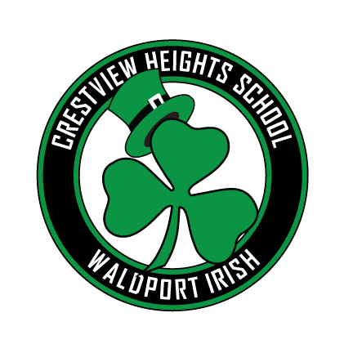

# Crestview Heights Elementary

Volume 2 Issue 6 February, 2019

## Our School Family Newsletter

## A Message from the Principal

### SPECIAL ANNOUNCEMENTS

This week we began using LCSD online HelpCounter to process and manage volunteers. This will help simplify and speed up the process. If you haven’t been approved as a volunteer this year, you can now do it online. Visit the following link, which is also live on our school website.

<https://www.helpcounterweb.com/welcome/apply.php?district=lincolncounty>

one of the 8 essentials: respect, honesty, patience, commitment, selflessness, kindness, forgiveness and humility. Be sure to allow emails from [jared@laudablestudents.com](mailto:jared@laudablestudents.com)

so they do not end up in your ‘junk’ email.

Also, please do not reply to the email you receive from laudable. This is the company that is hosting our data.

We are excited to let you know of an new tool we will be implementing in the next couple of weeks. When teachers or staff members see students demonstrating one or more of our school’s expectations of being safe, kind or helpful, parents may receive an email, or a postcard if there is no email on file. In addition, we will also include recognizing students for demonstrating

FEBRUARY 2019

Thursday, January 31 Free Bingo and popcorn Crestview cafeteria. Concessions for sale.

January 31

End of 1st Semester

Friday, February 1 Records day - No School.

Monday, February 4 Professional Day for teachers - No School

Tuesday, February 12 Booster Meeting 6:00

Monday, February 18 Holiday, No School

Thursday, February 21 – Interactive Math and Science Family Night – 5:30-7:00

Thursday, February 28 – ASP Family Night 5:00-7:00

Friday, March 1

Read Across America

6:00-7:30

### Congratulations to the Future Chef Finalists

### 40-Day Character Strong Challenge

Next week, January 28, we will begin our school-wide 40-day challenge around the 8 essentials. For the next 8 weeks, we will focus on one of the 8 essentials each week with a daily discussion, as well as a daily challenge. This will take us up to spring break, if you can believe it. Over spring break, we are challenging students to demonstrate each of the 8 essentials and keep a record to bring back to share with their class. Students who extend the challenge over the spring break and bring in documentation on how they did, will be recognized at the next school assembly.

Joe Huffman - 3rd grade, Mrs Saxton

Kassidy Huffman - 5th grade, Mrs Forshee

Evan Morgan (returning National Finalist from 2018) - 5th grade, Mrs Moser

### National School Counseling Week Feb. 4-8.

We are so blessed to have counselors in all of our schools in the district this year. Ms. Evans has become a vital part of our school family and so happy that she calls Lincoln County her home.

To receive emails or text messages through REMIND for Crestview Heights, follow these directions:

**TEXT** - Enter 81010 then text this in the message: @toneca

**WEBSITE** - Visit the following website and follow directions: [www.remind.com/join/toneca](https://www.remind.com/join/toneca)

It is January and teachers are working hard to help students become independent. Habitually doing things for children that they are capable of doing themselves can sometimes send a message that we don’t have confidence in their abilities. The outcome can be a child who lacks independence, self-esteem and problem-solving skills and who can’t – or won’t do age-appropriate tasks. Teachers not only teach academics and social skills, they also help students become independent and task-oriented. Parents, please support your teachers by dropping off your kids and encouraging them to take it from there, accepting the responsibility of transitioning into the classroom on their own.

### Celebrating our K-1 Students

### Positive Behavioral Expectations

It’s a good day to be Irish!

BEing SAFE * BEing HELPFUL

and BEing KIND

Our School Family Newsletter