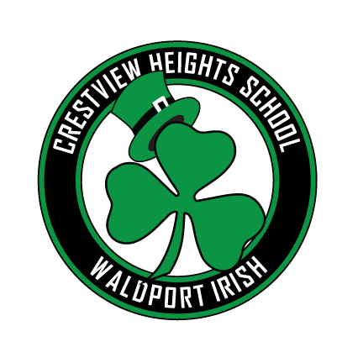

# Crestview Heights Elementary

Volume 2 Issue 1

September, 2018

Our School Family Newsletter

Welcome to a new academic school year at Crestview Heights. It was a busy and productive week for teachers at Crestview; full of planning, meetings, and getting ready for students. Our first week with was so exciting.

## A Message from the Principal

Beginning next year, in September, we will be sending out a school newsletter each month to keep families informed. In addition, there may be additional communication that needs to go out during the month that didn’t make it to the newsletter. Be sure to visit our new website, which also has current information. We will not be using *Living Tree* next year since it is rather costly and many felt it was underused this past year. We hope to post pictures on our school website as well as the district website.

with evening sports with their children, which makes it difficult to find a time that is doable for everyone. If you are unable to join us for lunch on the last day of school, please feel free to stop by and introduce yourself. Many of you have already done this and I look forward to meeting more of the families in our school community. Your child will be bringing home a note soon for you to let us know if you will be attending the BBQ so we will have enough to go around.

Requests from the health room

Remember that outgoing 6th graders will need to have their TDAP immunization prior to entering seventh grade in the September.ptember. 



We are so pleased to welcome the following individuals to our school family here at Crestview.

* Grades 3:4 - Sheryl Saxton who comes to us from Oceanlake Elementary
* Kindergarten - Melissa Butler who has been working in the district for many years
* First Grade – Devon Schmidt who moved from Portland, originally from California
* Counselor – Lauren Evans who moved to Oregon from Maryland
* Title position (5.5 hours - computers) – Krissy Pankey who worked in SPED last year as a temp
* Title position (5 hours) – Tandi Smallwood

We are so excited to have such quality staff supporting the students and families in Waldport! The following is the schedule of events for our first week back before the students arrive:



Hello! My name is Lauren Evans and I will be the school counselor for Crestview Heights.  I am so excited to get started in this position.  Because the position is new, I wanted to help parents to become aware of what my role will be in helping your student have a successful school year.  There are three direct ways that I can be involved in the life of a student.  These are classroom lessons, small group counseling units, and individual counseling.  I am also here to be a resource for you to help connect you with community resources and strategies to help your child be successful at home.  If you have any questions for me or any concerns, please feel free to contact me here at school.  I am here to help and support both you and your child.  I look forward to hearing from you.

### Counselor’s Corner

### New Staff

Important Dates:

* No school Friday, May 25. This is a Professional Development Day for Teachers.
* No school Monday, May 28 – Memorial Day. Have a safe and fun long weekend.
* The Waldport Librarian will be at our assembly on June 1 and will then be visiting all classrooms during the day on June 5.
* Last day of school is Friday, June 15. This is a half day with a BBQ lunch. Parents are welcome.